Endless Runner Game
Lab Overview
In this lab, we will create a basic 3D Endless Runner game in Unity.
Features We Will Implement:
- Player movement (forward, left-right)
- Physics-based movement using Rigidbody
- Platform setup
- Obstacles with collision detection
- Prefabs
- Coins and score counter
- Jump mechanic
- Physics Material (friction control)
- Game restart on death
- Game starts by pressing a start button

Step 1: Create the Platform

1. Create a New 3D Project
- Open Unity Hub
- Create new 3D project

2. Create the Ground Platform
- Right click Hierarchy → 3D Object → Cube
- Rename to Platform or Ground
- Scale it:
  - X = 5
  - Y = 1
  - Z = 50
This will be the running track.

Step 2: Create the Player

1. Add Player Object
- Right click → 3D Object → Cube
- Rename to Player
- Position it slightly above the platform

2. Add Physics Components
On Player:
- Add Rigidbody
- Add Box Collider
On Platform:
- Make sure it has Box Collider

3. Test
Press Play.
You should see:
- Player cube falls
- It lands on the platform
Important Rule
For collisions to work:
- Both objects must have a Collider
- At least ONE must have a Rigidbody
If Rigidbody is on both:
- Platform must be Static OR
- Freeze position on Platform Rigidbody

Step 3: Add Infinite Forward Movement
Create a new script: PlayerMovement.cs
Attach to Player.
Basic Transform Movement (Initial Version)
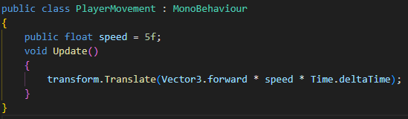
Press Play
Player moves forward infinitely.

Step 4: Add Materials

Create Materials
- Right click in Project window → Create → Material
- Create:
  - PlatformMat
  - PlayerMat

Customize:
- Change Albedo/Base color
- Adjust Smoothness
- Try Metallic

Assign Materials
- Drag material onto objects

Step 5: Make Camera Follow Player
- Drag Main Camera onto Player
- Reset position
- Adjust slightly above and behind
Now camera moves with player.
- Explain Parent and Child object relation.

Step 6: Create Obstacles

1. Create Obstacle
- Add Cube
- Resize them
- Rename: Obstacle

2. Create Prefab
- Drag Obstacle into Project folder
- Delete from scene
- Drag multiple copies

3. Add Tag
- Select obstacle
- Add Tag → Create new tag → "Obstacle"
- Assign tag

Step 7: Add Collision with Obstacles
Update Player script:
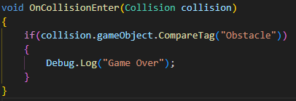

Step 8: Problem with Transform Movement
Explain:
When using:
transform.Translate()
We bypass physics engine.
Problems:
- Collision feels unnatural
- Object may clip (go through eachother)
- No realistic force interaction

Step 9: Convert to Rigidbody Movement
Modify script:
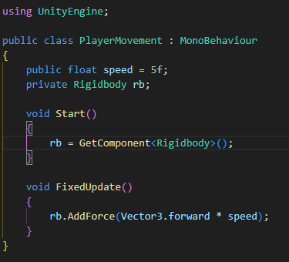
Explain:
- Physics code → use FixedUpdate()
- Rigidbody movement → smoother collisions

Step 10: Add Physics Material

Create Physics Material
- Right click in project window→ Create → Physic Material
- Name: LowFriction
Set:
- Dynamic Friction = 0
- Static Friction = 0
- Friction Combine = Minimum
Assign to Player Collider.
Explain:
- Friction controls sliding resistance.

Step 11: Add Left & Right Movement
Modify FixedUpdate:
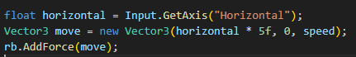
Now:
- A / D or Arrow Keys move sideways

Step 12: Add Coins

Create Coin
- 3D Object → Cylinder
- Scale small
- Create prefab
- Add Tag: "Coin"

Make Coin Trigger
- Select coin collider
- Check Is Trigger

Add Coin Collection
In Player script:
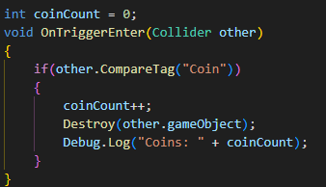

Step 13: Add Jump
Add:
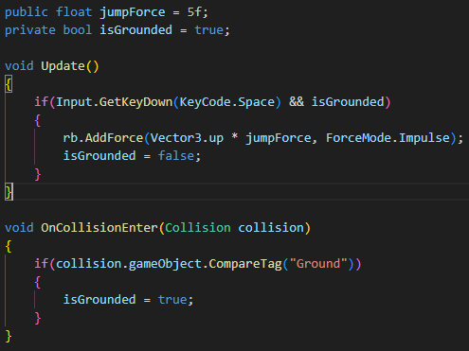
Make sure platform tag = "Ground"

Step 14: Restart on Death
Add:
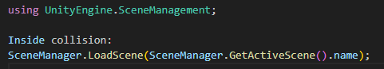

Step 15: Add Start System
Add:
public bool gameStarted = false;
Modify movement:
if(!gameStarted) return;

